Tool Summary Sheet
Tool: | Individual Randomized Trial Independent Monitoring Meeting Report Form
Purpose: | MS Word template to be used as a starting point for preparing a DSMB report
Audience/User: | Statisticians and Principal Investigators responsible for preparation of DSMB reports
Details: | This template includes a proposed structure for a DSMB report as well as draft language and other guidance
Best Practice Recommendations: | - Review this template several months prior to the date of the first DSMB meeting, and customize to the specific needs and requirements of the study.  - In the template, the instructions and explanatory text are indicated by {blue italics} Instructional text will also be enclosed in braces to signify this text for screen-readers used by the visually impaired.  - Text enclosed with <> is a placeholder for a specific detail (e.g., <protocol title>); replace as appropriate.  - Delete template-specific instructional text as well as this Tool Summary Sheet during the report development process.  - Leave the template version information in the lower left hand corner of the document.  - It is easiest and cleanest to use the styles that are embedded in the document, rather than to create your own. (In MS Word 2007: From the Home menu, select the bottom right arrow key to bring up the styles box, select “Options”, under “Select Styles to Show” select “in current document”.)  - Ensure that all placeholder and example text is replaced with the study specific information.
Tool Revision History:
Version Number | Version Date | Summary of Revisions Made:
1.0 |  | First approved version

DATA AND SAFETY MONITORING BOARD MEETING REPORT
Protocol Title: | <Insert title of the protocol>
Protocol Number: | <Insert protocol number>
Protocol Version: | <Insert version number and date of current protocol>
Principal Investigator: | <Name of PI  PI’s Title  Institution  Address>
meeting date: | <Insert date of the scheduled meeting>
Date REport Issued: | <Insert date that the report is being issued>
Data Cutoff Date: | <Insert the date of the data snapshot for the analyses in this report>
Date of last data review: | <Insert date of last DSMB meeting>
prepared by: | <Name of person who prepared the report  Person’s Title  Place of employment  Address>

Table of Contents
{This table uses the Table of Contents function in Microsoft Word that will automatically update headings and page numbers used in the body of the report. In the body of the report, add, delete, or modify headings as needed in order to best reflect your study.}
Tool Summary Sheet 1
DATA AND SAFETY MONITORING BOARD MEETING REPORT 2
Executive Summary 4
Protocol Synopsis 6
1.0 Report Overview 7
2.0 Response to Most Recent DSMB Recommendations/Requests 7
3.0 Study timeline 8
4.0 Enrollment Status 8
5.0 Subject Status 10
6.0 Demographics (and Baseline Characteristics if Appropriate) 12
7.0 Protocol Implementation 13
7.1 Intervention Adherence 13
7.2 Protocol Deviations 13
8.0 Safety 14
8.1 Stopping Rules 14
8.2 Serious Adverse Events 14
8.3 Deaths 15
8.4 Unanticipated Problems 16
8.5 Other Clinical Assessments 16
9.0 Quality Management 16
10.0 Outcomes Data 17
Appendix A: Additional Summary Tables 18
Appendix B: Additional Figures 19
Appendix C: Additional Data Listings 20

Executive Summary
{Add, delete, or modify summary topics as needed.}
Report Overview | {Example text:}  This report reviews enrollment and safety data available in the study database as of [Month Date, Year]. Summary tables are provided in the body of the report. Additional tables and figures referenced in the report are provided in the Appendices.
Study Site Status | {Example text:}  XX of the XX study sites have been activated. The XXth will be activated this month.
Enrollment Status | {Example text:}  - XX subjects have been screened for this study.  - XX subjects have been enrolled.
Subject Status | {Example text:}  - XX subjects are awaiting dosing/intervention.  - XX subjects have completed Intervention session 1.  - XX subjects have completed Intervention session 2.  - XX subjects have completed the protocol.  - No treated subjects have been discontinued (withdrawn) from the study.
Stopping Rules  <or Halting Rules or Suspension Guidelines>  {Use terminology that matches the protocol throughout this report} | {Example text:}  No stopping rules have been met since the previous DSMB review.  Or  There are no new “Alerts” since the previous DSMB review.
Safety Summary | {Example text:}  - XX serious adverse events have occurred in XX subjects.  - XX serious adverse events were reported in the previous DSMB report.  - Of the XX serious adverse events, YY were considered related to study intervention.
Protocol Deviations | {Example text:}  - XX protocol deviations associated with XX subjects have been reported.  - None of the deviations has impacted subject safety.  - XX deviations have impacted scientific integrity
Quality Management | {Example text:}  Quality management reviews are performed quarterly and were last completed on [Month Date, Year] and [Month Date, Year].

Protocol Synopsis
{Add, delete, or modify protocol headings as required. Enter appropriate information in second column; some clarification guidance has been provided.}
Protocol Title | <Insert protocol title>
Principal Investigator | <Insert name of Principal Investigator>
Study Sites | <List name of each study site>
Study Activation Date | <Insert activation date of first site>
Planned Accrual | <Insert planned number of participants to be enrolled>
Planned Accrual Period | <Insert time (months, years, etc.)>
Planned Duration | <Insert time from first participant-first visit to last participant-last visit (months, years, etc.)>
Study Design | <Briefly describe study design>
Study Objectives | <Briefly describe study objectives>
Intervention Description | <Briefly describe study Intervention(s)>
Inclusion Criteria | <List inclusion criteria>
Exclusion Criteria | <List exclusion criteria>
Study Outcomes | <Briefly describe study outcomes>
Study Stopping Rules  <or Halting Rules or Suspension Guidelines>  {Use terminology that matches the protocol throughout this report. Replace headings as appropriate.} | <Clarify stopping rules or suspension guidelines>
{Add, delete, or modify headings as needed in order to best reflect your study. Place summary tables, listings, and figures within the body of the report; however, if the tables, listings, or figures are long, place them in the Appendices. For small numbers of subjects, listings may be more appropriate than summary tables.}

Report Overview
{Example text:}
The purpose of this report is to review cumulative enrollment and safety data for the subjects enrolled in the XXX study. This report reflects data from the study database as of [Month Date, Year]. Within the body of the report are summary tables of enrollment, demographic characteristics, and adverse events. Additional tables, listings, and figures referenced in this report are provided in Appendices A-C. There have been XX DSMB meetings for this study, and the last review was on [Month Date, Year]. At that time, the DSMB concluded that the available safety data supported the continuation of the trial. Readers of this report are asked to maintain the confidentiality of the information provided in this report.

Response to Most Recent DSMB Recommendations/Requests
{Identify DSMB recommendations/requests from the last meeting and clarify how those requests have been handled in the report and/or elsewhere. If this is the first DSMB meeting for this protocol or no previous recommendations/requests were made, indicate as such in this section. Doing so will provide a future reminder to the author who is likely to use the previous report as a starting point for the subsequent report.}

Study timeline
{Provide an overview of study flow with projected timeline. Include times of last patient enrolled, Follow up completion, and completion of final analysis. See sample figure below.
Sample Figure:}
Figure #. Study Timeline

Enrollment Status
{Describe enrollment and provide a summary table (see example below). Provide enrollment statistics by site if the study involves multiple sites. If the study is enrolling, provide the subject accrual target and estimated time to completion of enrollment. A figure showing expected/planned versus actual enrollment is helpful, , both by site and aggregated (see example on next page).
Sample Table:}
Table #. Subject Enrollment Status for All Subjects
Type – N (%) | Site A | Site B | Site C | Total
Pre-Screened
Consented and Screened
Eligible
Randomized

{Sample Figure:}
Figure #. Number of Subjects Enrolled by Month,
Expected versus Actual Accrual
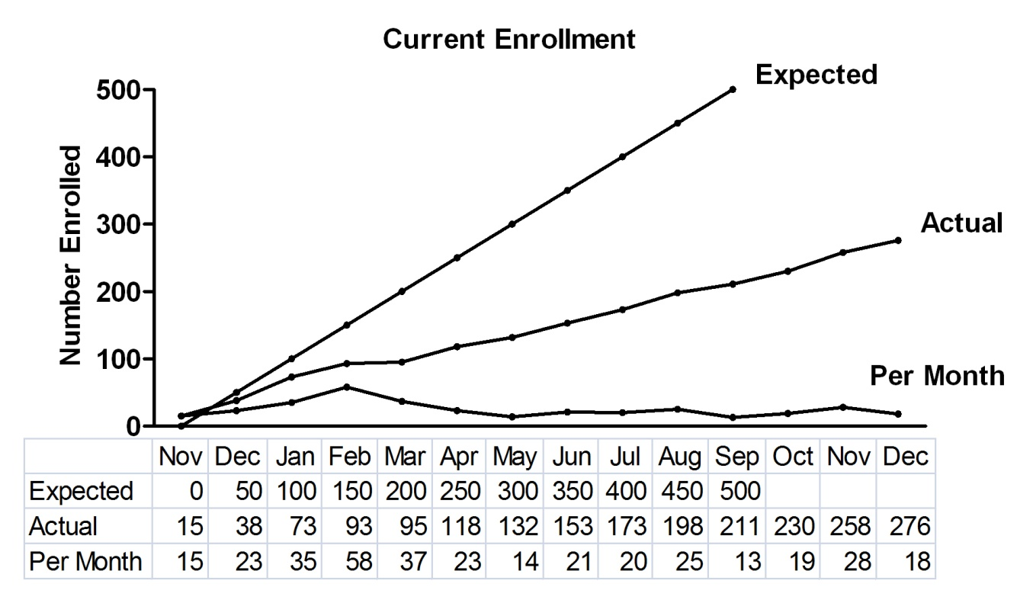

Subject Status
{Describe where patients are in the study in relation to major milestones, such as the number of subjects who have completed the baseline visit, the dosing visit, year 1 follow-up, and the final study visit. A summary table providing the study milestones and the number of subjects who have completed those milestones is recommended (see example).
Also, provide the number of subjects who were terminated and the reason for their termination, such as voluntary withdrawal, death, lost to follow-up, adverse event, or completed the protocol. A summary table of subject disposition is also recommended. For some protocols, it is important to distinguish between subjects who withdrew early from the study and those who discontinued Intervention but may or may not still be followed.}
{Sample Table:}
Table #. Status of Randomized Subjects, by Study Site
Type – N (%) | Site A | Site B | Site C | Total
On Study
Number of Doses or Intervention Sessions
1
2
3
Completed the Intervention
Completed the Follow-up Visits
Prematurely Discontinued

{A modified CONSORT flow diagram¹ can also be included to summarize enrollment and patient participation progress.}
¹. Moher D, Schulz KF, Altman D. The CONSORT statement: revised recommendations for improving the quality of reports of parallel-group randomized trials. JAMA 2001;285:1987-91.
{Sample Diagram:}
Analysis
Allocation
Follow-Up
Enrollment
Analysed (n= )
♦ Excluded from analysis (give reasons) (n= )
Lost to follow-up (give reasons) (n= )
Discontinued intervention (give reasons) (n= )
Allocated to intervention (n= )
♦ Received allocated intervention (n= )
♦ Did not receive allocated intervention (give reasons) (n= )
Randomized (n= )
Excluded (n= )
♦ Not meeting inclusion criteria (n= )
♦ Declined to participate (n= )
♦ Other reasons (n= )
Assessed for eligibility (n= )

Demographics (and Baseline Characteristics if Appropriate)
{Describe the demographic characteristics (age, race, and ethnicity) and key baseline characteristics of enrolled subjects (if appropriate). Provide a summary table (see example below).
{Sample Table:}
Table #. Baseline Patient Characteristics, by Study Site
Patient Characteristics | Site A | Site B | Site C | Total
Age, mean (SD)
Gender – Female, N (%)
Race, N (%)
Ethnicity, N(%)
Baseline health conditions, including measures of pain and/or function
Baseline comorbid conditions, including substance use

Protocol Implementation
{Assess protocol implementation, including adherence to protocol participation rules and study follow-up. Report protocol deviations and/or violations.}

Intervention Adherence
{Summarize Intervention adherence, including number of doses/intervention sessions completed and missed, as well as reasons for non-adherence.
Sample Table:}
Table #. Intervention Adherence
Adherence Assessment – N (%) | Site A | Site B | Site C | Total
Attended XX or more sessions
Attended less than XX sessions
Loss to follow up
Overall adherence
Reasons for non-adherence

Protocol Deviations
{Summarize or list protocol deviations that have occurred since the previous DSMB report and over the course of the study.}

Safety

Stopping Rules
{List and describe any stopping rules that have been triggered since the previous DSMB report and over the course of the study.}

Serious Adverse Events
{Summarize all serious adverse events (SAEs) that have occurred since the previous DSMB report and over the course of the trial. Provide information on relatedness to treatment and study procedures (see an example of a summary table below). Provide information on expedited reports, and include MedWatch forms in the Appendix if applicable. In addition, a summary table of subjects experiencing adverse events by treatment group, system organ class, and preferred term should be considered. Extensive listings may be placed in the Appendix.
Sample Tables:}
Table #. Summary of All Serious Adverse Events for Consented Subjects
Topics -- N (%) | Site A | Site B | Site C | Total
Number of SAEs reported
Number of Subjects with SAEs [1]

Number of SAEs by Relatedness to Intervention | Site A | Site B | Site C | Total
Not Related
Related
Possible
Probable
Definite
Subjects with SAEs by Relatedness to Intervention [2] | Site A | Site B | Site C | Total
Not Related
Related
Possible
Probable
Definite

[1] Subjects who experience one or more SAEs are counted only once.
[2] Subjects are counted only once within a particular severity grade or relatedness category.

Number of SAEs by System Organ Class (SOC) and Preferred Term | Site A | Site B | Site C | Total
SOC 1
Preferred Term 1
Preferred Term 2
SOC 2
Preferred Term 1
Preferred Term 2
………

Deaths
{ List, describe and summarize all deaths that have occurred since the previous DSMB report and over the course of the study.
Sample Listing:}
Listing #. Listing of Deaths
Subject ID | Study Site | Age (yrs) | Gender | Randomization Date | Date of Death | Cause of Death | Relatedness to Treatment
{Sample Table:}
Table #. Summary of Deaths
Death | Total
N (%)
Age, mean (SD)
Gender – Female, N (%)
Race, N (%)
Ethnicity, N(%)
Relatedness to Intervention – Yes, N(%)

Unanticipated Problems
{Summarize or list unanticipated problems. The Office for Human Research Protections (OHRP) considers unanticipated problems, in general, to include any incident, experience, or outcome that meets all of the following criteria:
1. Unexpected (in terms of nature, severity, or frequency) given (a) the research procedures that are described in the protocol-related documents, such as the IRB approved research protocol and informed consent document, and (b) the characteristics of the subject population being studied;
2. Related or possibly related to participation in the research (in this guidance document, possibly related means there is a reasonable possibility that the incident, experience, or outcome may have been caused by the procedures involved in the research); and
3. Suggests that the research places subjects or others at a greater risk of harm (including physical, psychological, economic, or social harm) than was previously known or recognized.
OHRP notes that an incident, experience, or outcome that meets the three criteria above generally will warrant consideration of substantive changes in the research protocol or informed consent process/document or other corrective actions in order to protect the safety, welfare, or rights of subjects or others.}

Other Clinical Assessments
{You may list types of tests, such as laboratory findings, imaging or physical examinations, as separate headings.
Summarize any other clinical assessments that are being monitored for subject safety. Results may be presented as summary tables, listings by subject, or plots. Depending on the study, identify by subject any significant changes from baseline, results that are clinically significant, or results that are considered adverse events.}

Quality Management
{Provide details regarding quality management activities completed since the last DSMB review, including frequency. Summarize or list findings and identify measures or corrective actions taken to address the findings or issues.}

Outcomes Data
{As a general rule, interim results should not be performed or presented unless interim analyses are described in the protocol or the DSMB has requested an interim analysis to assess a safety concern or study futility. The decision whether or not to present interim or final results in this report, or to present results in an open or closed session, should be discussed with the DSMB and the study sponsor.}

Appendix A: Additional Summary Tables
{It is likely that these Appendices will originate as separate electronic files created by SAS or some other statistical software. If you are creating an electronic version of the full report, use Adobe pdf (or equivalent) to combine the files with this document in a “published” Adobe report. It is very useful to include a Table of Contents or, at a minimum, a list of items contained within each Appendix (e.g., a list of table numbers and names).
Page numbering of the contents of the Appendices are at the discretion of the document owner. Each Appendix file can 1) begin at page 1 or 2) can be numbered contiguously with this document. The second option is advantageous but more difficult to achieve.
A subset of these items may also have been inserted into the report. It is acceptable to also include those items in the corresponding appendix. All other displays that are not inserted into the body of the report should be included herein. It is good practice to ensure that all post-text displays are referenced somewhere in the body of the report.
Include post-text Summary Tables here.}

Appendix B: Additional Figures
{Include post-text Figures here.}

Appendix C: Additional Data Listings
{Include post-text Data Listings here.}

